LP3 (DAA) Lab Exp No.5

import random

def partition(arr, p, r):

x = arr[r]

i = p - 1

for j in range(p, r):

if arr[j] <= x:

i += 1

arr[i], arr[j] = arr[j], arr[i]

arr[i + 1], arr[r] = arr[r], arr[i + 1]

return i + 1

def quick_sort(arr, p, r):

if p < r:

q = partition(arr, p, r)

quick_sort(arr, p, q - 1)

quick_sort(arr, q + 1, r)

def random_partition(arr, p, r):

i = random.randint(p, r)

arr[i], arr[r] = arr[r], arr[i]

return partition(arr, p, r)

def randomized_quick_sort(arr, p, r):

if p < r:

q = random_partition(arr, p, r)

randomized_quick_sort(arr, p, q - 1)

randomized_quick_sort(arr, q + 1, r)

def main():

input_str = input("Enter the list of numbers (space-separated): ")

arr = list(map(int, input_str.split()))

n = len(arr)

randomized_quick_sort(arr, 0, n - 1)

print(' '.join(map(str, arr)))

if __name__ == "__main__":

main()

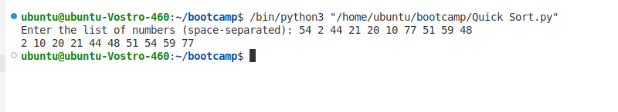OUTPUT: